 | 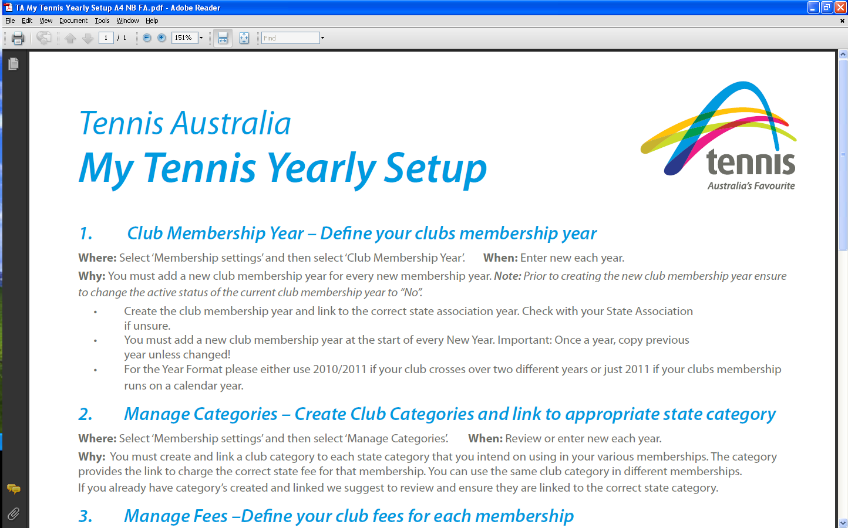  Beaumont Tennis Club  Junior Membership Form: Summer 2024/25
Member Details – Please add the required details
GIVEN NAME | FAMILY NAME |  | GENDER (male / female) | DATE OF BIRTH (dd mmm yy)
MAILING ADDRESS |  | PARENT(S)’ NAME(S)
PARENT’S MOBILE PHONE NO. |  | PARENT’S EMAIL
PLAYER’S MOBILE PHONE NO. (OPTIONAL) |  | PLAYER’S EMAIL (REQUIRED IF 15 OR OLDER)

Terms and Conditions and Privacy
‘I agree to abide by the rules of tennis and behaviour codes of the Beaumont Junior tennis group and coaches. This includes dress, language and court etiquette, punctuality and, most importantly, teamwork and good sportsmanship.’
I hereby apply to be a member of Beaumont Tennis Club and agree to be bound by the Beaumont Tennis Club’s constitution and policies, as well as the rules, regulations and policies of Tennis South Australia.
For information on the Club’s policies see www.beaumont.org.au/policies.html. Tennis Australia’s policies may be found at www.tennis.com.au/about-tennis-australia/reports-and-policies/policies.
I will ensure that I have a Competitive Player Profile, which involves linking my Tennis ID and Universal Tennis Rating (UTR). Instructions can be accessed at https://www.tennis.com.au/competitiveplay/create-your-cpp.
Signed: Parent Player
Dated: / /

Membership Options
A payment is included (fees should be paid before the first match)
☐ | Junior summer competition: | $190
☐ | Junior competition with a Sports Voucher: | $90
☐ | Club shirt: | $40
Sports Vouchers:
Sports Vouchers may be used on behalf of children up to Year 9 for payment ($100) towards Beaumont Junior competition membership. See www.beaumont.org.au/membership.html
Pay by Electronic Funds Transfer:
Make direct transfer to the Beaumont Tennis Club’s bank account: BSB: 105027 Account number: 129704240. Please include the member’s name in the message field AND provide a filled-in copy of this form to Chris Bagley (Treasurer) or Garry Byrne (Junior Coordinator).
Pay by cash:
Please give this completed nomination form and your payment to Chris Bagley (Treasurer) or Garry Byrne (Junior Coordinator).

SPORTS VOUCHER DETAILS:
Additional information is required in order to claim a Sports Voucher.
Child’s information
I confirm my child has not already claimed a voucher in 2024 | Yes ☐ |  | No ☐
I wish my child to claim a 2025 voucher | Yes ☐ |  | No ☐
Is this the first time your child has joined this activity provider? | Yes ☐ |  | No ☐
Has your child been identified as living with a disability? | Yes ☐ |  | No ☐
Is English the main language spoken at home? | Yes ☐ |  | No ☐
If no, what language do you speak at home?
Is your child from an Aboriginal or Torres Strait Islander background? |  | Yes ☐ |  | No ☐
Medicare information
Medicare number: | _ _ _ _ _ _ _ _ _ _ | Reference number: | _
OR Australian visa number:

